

# Panasonic Cordless Everyday Living: KX-TG7892AZS

## Type of device: Landline - Cordless

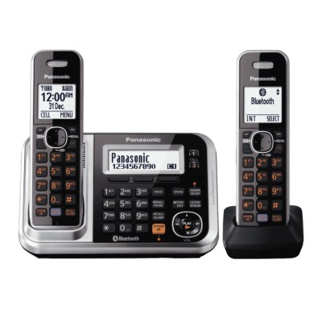

*This phone connects via Bluetooth to Bluetooth enabled mobile phones, headsets and neck loops for hearing aids. The sound is clear with plenty of volume.*

Button Type : Physical Keypad

Average Price : $125 as of 19 12 2019

## Accessibility Features:

### Hearing Impairment and Deaf

* Bluetooth or Wi-Fi

Visual Alerts - Incoming Calls

### Vision

* Bluetooth or Wi-Fi
* Brightness Adjustable
* Key Marker – Raised '5'

Key Numbers - Standard Layout

### Physical

* Bluetooth or Wi-Fi
* Guarded/Recessed Keys
* Physical Dialling Keys

Speaker-phone option

## How and where to get it from?

You can buy this phone from [The Good Guys](https://www.thegoodguys.com.au/panasonic-cordless-phone-twin-pack-kx-tg7892azs), [JB Hi-Fi](https://www.jbhifi.com.au/products/panasonic-kx-tg7892azs-cordless-phones-with-answering-machine-twin-pack?q=KXTG7892AZS), [Bing Lee](https://www.binglee.com.au/search?q=KXTG7892AZS&page=1&limit=36&sort=relevance&mode=grid&type=products), [Retravision](https://www.retravision.com.au/panasonic-kxtg7892azs), and other retailers.

## More information is available on:

[Panasonic Cordless Everyday Living: KX-TG7892AZS Webpage](https://www.panasonic.com/au/support/product-archives/household/cordless-phones/phone-with-answering-machine/kx-tg7892azs.html)

[Panasonic Cordless Everyday Living: KX-TG7892AZS User Manual (PDF Download)](https://www.panasonic.com/content/dam/Panasonic/support_manual/Cordless_Telephone/English_03-other/KX-TG7892_7893AZS.pdf)